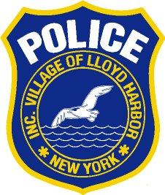

**VILLAGE OF LLOYD HARBOR**

**SECURITY AND FIRE ALARM PERMIT REGISTRATION**

NAME:________________________________________________________________________ PHONE#________________________________CELL#__________________________________

ADDRESS:______________________________________________________________________

NAME-ADDRESS OF ALARM CO.____________________________________________________

THIS APPLICATION IS FOR: (Check all that apply) ( ) POLICE ( ) FIRE

ALARM SYSTEM IS: (Check one) ( ) EXISTING ( ) NEW DATE INSTALLED ____________

***IT IS UNDERSTOOD AND AGREED BY THE UNDERSIGNED THAT***

1. *The alarm system is considered only as a convenience to the premises owner and an operational aid to the police and/or fire department.*
2. *The police and/or fire department shall not be held liable for any failure to respond to an alarm.*
3. *This application is subject to the approval of the Police Chief or Fire Chief and may be revoked by the Village.*
4. *The permit holder shall allow inspection of the alarm system by authorized representatives of the Police or Fire Department.*
5. *If the alarm system is activated and owner or authorized occupant is absent from the premises, the Police or Fire Department personnel shall be permitted to enter the premises without incurring any liability for the purpose of:*
6. *Searching for intruders*
7. *Extinguishing fires*
8. *Making necessary adjustments to the alarm system*
9. *The applicant hereby acknowledges that:*
10. *He/she has read or is familiar with the Village Local Law regarding alarm systems.*
11. *He/she shall be responsible for paying all charges for false alarms.*
12. *A permit must be issued for any new resident or before system is installed.*

**THIS APPLICATION MUST BE FILED ALONG WITH THE FEE OF $10.00**

**MAKE CHECKS PAYABLE TO THE VILLAGE OF LLOYD HARBOR**

*____________________________________*

*Signature of Applicant Date*

*Police Chief______________________ Date________*

*Fire Chief________________________ Date________ 12/23*